Aptocine-Mediated Systemic Immune Tumor Destruction
  - An Emerging Intratumoral Whole Cell Autologous Vaccine

The branch of cancer immunotherapeutics leading to the vaccine effort arguably began with Coley’s use of bacterial toxins to induce immune activation around the turn of the twentieth century.¹ Through the experience gained in dozens of cancer vaccine trials and a multitude of preceding preclinical studies, a number of approaches have been defined, along with the associated major development problems and challenges. The lack of a licensed therapeutic cancer vaccine underscores the difficulty of the approach, ascribable to a number of complex and interrelated factors. Chief among the factors is the underlying global immune dysregulation in patients with advanced cancer, in particular the tumor microenvironment. Malignant tumors adapt in multiple ways to avoid immune attack, including downregulation of tumor antigens on the cell surface, production of inhibitory cytokines, and induction of anergy in infiltrating lymphocytes—all of which overwhelm any attempts to stimulate innate and adaptive immunity.²
Immune effects from light-activated drugs have been reported extensively in preclinical settings, including the use of light activation ex vivo to generate cancer vaccines.³ In addition to solid preclinical evidence for vaccine effects, clinical responses ascribable to a vaccine-like effect have been noted recently.⁴⁻⁵ Retrospective review of imaging data from clinical studies conducted by Light Sciences Oncology, using AptocineTM (talaporfin sodium), a novel light-activated drug treatment, has also revealed strong case-series evidence for tumor response consistent with vaccine-like effects. Ongoing Aptocine preclinical studies bolster the clinical observations by defining the mechanisms of vaccine action.
Aptocine is a water-soluble drug targeted inside a tumor or other tissue by a small, single-use, disposable drug activator included with the drug. The drug activator contains a tiny array of LEDs, located at the end of a very narrow (only 1.2 mm wide) flexible coated micro-wire, that emits red light at a discrete frequency and intensity, for a fixed time period, to activate Aptocine and create a “treatment region” around the LED array. An activated Aptocine molecule causes the production of singlet oxygen which can kill target tissues with minimal side effects through vascular closure and apoptosis, or “programmed cell death.” Administering physicians insert the LED array into the targeted tumor or tissue, inject Aptocine intravenously and then energize the drug activator. The use of multiple drug activators and multiple treatments is common, and treatment regimens can be tailored based on the number, size, shape, and location of the target tumors.
- Now completing Phase 3 development for hepatocellular carcinoma and metastatic colorectal cancer, Aptocine offers triple potential mechanisms for fighting solid tumors: cytoreduction via direct apoptotic cell kill during treatment; complete vascular closure in the primary apoptotic area, yielding extension of the apoptotic zone via anoxia; and a tertiary systemic immune response due to a vaccine-like action. Studies have shown tumor apoptosis to be highly immunogenic.⁶
The Aptocine tertiary immune response is delayed and may occur over weeks after the initial local apoptotic effect. (See Figure: “Aptocine’s Likely Immune Mechanism.”) A similar delayed immune response has been noted radiographically in melanoma patients in Phase 2 anti-CTLA-4 antibody trials.⁷

Aptocine and Whole Cell Cancer Vaccines
A multitude of approaches have been developed to assist the recognition of tumor-associated antigens that are normally non-recognizable by the host immune system. Investigation of vaccine approaches has included the use of viral and bacterial vectors, peptide constructs, carbohydrate and protein antigens combined with autologous dendritic cells, and whole-cell preparations—all intended to stimulate some aspect of cellular or antibody-mediated immunity.⁸ Cell-based cancer vaccines employing whole tumor cells have received particular attention because specific antigens do not have to be identified in advance. Cell-based vaccines have been shown to stimulate antitumor effector cells in vivo.⁹ Vaccines have been constructed using allogenic as well as autologous cell lines.¹⁰⁻¹⁵ Advantages of cell-based vaccines⁹ include:
- Multi-antigen exposure from different tumor cells accounts for inherent tumor heterogeneity
- Stimulation of multiple clones of effector cells is enabled
- Tumor antigens need not be isolated in advance
Studies of drug/light activation to produce cancer vaccines ex vivo have been reviewed.^{10, 12-14} The Aptocine approach varies from prior reports in that:
Vaccine is generated in situ. In vitro techniques that have been used to create whole-cell based autologous vaccines have a number of significant drawbacks: 1) Tumor must be harvested—usually through surgery, which adds significant risks and pain and limits use in many patients; 2) Available tumor material may be insufficient for vaccine preparation; 3) Improper tumor-cell processing risks inadvertent live tumor-cell implantation at time of vaccination; and 4) Cancer stem cells may not be adequately addressed by the vaccine.^{11, 16}

On the other hand, Aptocine can be used to treat tumor deposits with safer minimally invasive techniques in an outpatient fashion. Lesions ranging from 2cm to greater than 20cm have been effectively treated, multiple lesions have been treated in single sessions, and retreatment of large and multiple lesions is common.¹⁷⁻¹⁹
Underlying immune dysfunction is corrected in concert with immune stimulation. By causing a gross reduction in total tumor volume¹⁹⁻²⁰ or in many cases complete tumor destruction, Aptocine treatment may disrupt the complex defensive immunosuppression created in the tumor microenvironment. Leukocytes and other immune cells may therefore be able to penetrate tumor tissue without becoming anergic or dysfunctional and can subsequently mount a response to proliferate and recruit additional cells for immune attack. Such enabling of immune cells may contribute to a prolonged attack on treated tumor tissue, as well as an enhanced ability to attack untreated tumors and prevent metastases systemically.
In ongoing studies, Aptocine has been shown to stimulate tumor-draining lymph nodes, causing in vivo generation of cytolytic CD8+ T cells that are tumor specific.²¹ Metastases were significantly inhibited in tumor-challenged animals that previously received leukocytes from an Aptocine-treated animal. The mammary fat pads of BALB/c mice were injected with the poorly immunogenic 4T1 cell line, which forms highly malignant and metastatic breast tumors. After Aptocine treatment of established tumors, draining lymph nodes were removed and the CD8+ T cells harvested. The cells became sensitized to the tumor cells due to Aptocine (unlike control mice), and were capable of killing tumor cells injected into non-treated mice.
Other preliminary preclinical data from studies combining Aptocine with anti-CTLA-4 antibodies indicates that Aptocine may potentiate the immunostimulatory action of the antibody (LSO data on file). Data using the TRAMP prostate cancer C57BL/6 mouse model demonstrate reduced tumor volume with Aptocine and Aptocine+ anti-CTLA-4 antibody compared to controls. Survival was prolonged in tumor-bearing mice treated with a high light dose of Aptocine versus controls. Further studies on synergistic effects of Aptocine combined with anti-CTLA-4 antibody are ongoing.
A current Phase 3 trial of Aptocine in patients with hepatic metastases from colorectal cancer includes analysis of response in untreated distant lesions. The study will add prospectively derived data in support of maximization of the vaccine effect by examination of Aptocine dosimetry and sequencing of treatment.
Vaccine is site- and patient-specific. Tumor heterogeneity between patients, between separate tumors, and within the same tumor in the same patient is a well-known issue even for autologous vaccines. Aptocine allows the immune system to select the patient-specific set of the most immunogenic antigens—in essence producing a personalized vaccine.²² Aptocine is repeatable—in theory there is no limit to the number of cycles of therapy a patient could receive, because no cumulative toxicity has been demonstrated. Aptocine’s repeatability allows for staged therapy of heterogeneous and multiple lesions.
Active tumor volume reduction occurs simultaneously with generation of vaccine. In addition to disrupting the tumor microenvironment, Aptocine treatment also reduces total tumor volume at the time of treatment.

Triple Action
Present cancer therapies on the market and in development attempt either to reduce tumor burden through an immediate but fleeting necrotic response or attack the tumor over time via systemic immune activation. Non-immunogenic treatments lack the capability to induce a lasting anti-tumor effect in patients, and immunotherapies tested to date have not been able to conquer the defenses created in the tumor microenvironment.
Aptocine has the potential to reduce tumor volume in the short term while also activating the immune system to prolong and broaden the attack. The relief of immunosuppressive tumor load, with multi-antigenic presentation and cytolytic T-cell stimulation, not only targets a primary tumor but may also protect against distant lesions and new metastases. Aptocine’s novel triple action on lesions regardless of size, number, and location potentially represents the best way forward in patients with heterogeneous tumor growth.
[Figure and References below.]

Figure: Aptocine’s Likely Immune Mechanism
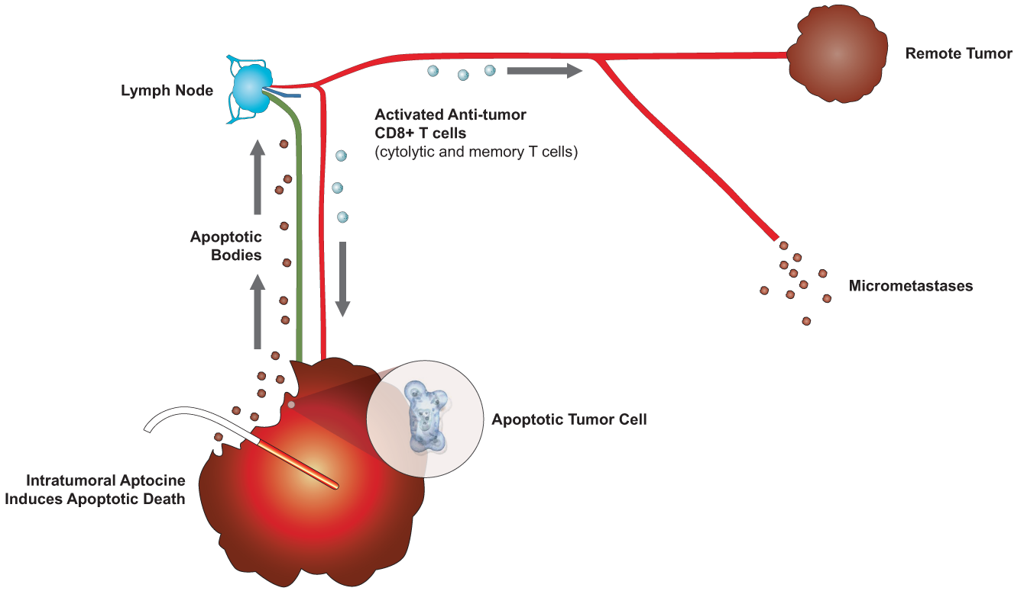
Aptocine induces apoptosis in the main tumor mass, which generates immunogenic tumor antigens and blocks release of tumor-promoting and immunosuppressive factors simultaneously. The dual effect may lead to effective therapeutic vaccine action in the face of advanced disease, an outcome heretofore not demonstrated in any clinical vaccine trial.²³⁻²⁴

References
1. Dalgleish AG. Recent progress in immunotherapy: anti-cancer vaccines, emerging clinical data. Ann Oncol 2008;19 Suppl 7vii248-51.
2. Finn OJ. Cancer immunology. The New England journal of medicine 2008;358(25):2704-15.
3. Light Sciences Oncology. Litx and Immunogenicity (unpublished report). Bellevue, WA: Light Sciences Oncology, Inc.; 2008 Dec 2008 Update.
4. Thong PS, Olivo M, Kho KW, et al. Immune response against angiosarcoma following lower fluence rate clinical photodynamic therapy. J Environ Pathol Toxicol Oncol 2008;27(1):35-42.
5. Thong PS, Ong KW, Goh NS, et al. Photodynamic-therapy-activated immune response against distant untreated tumours in recurrent angiosarcoma. Lancet Oncol 2007;8(10):950-2.
6. Goldszmid RS, Idoyaga J, Bravo AI, Steinman R, Mordoh J, Wainstok R. Dendritic cells charged with apoptotic tumor cells induce long-lived protective CD4+ and CD8+ T cell immunity against B16 melanoma. J Immunol 2003;171(11):5940-7.
7. Weber J. Ipilimumab: controversies in its development, utility and autoimmune adverse events. Cancer Immunol Immunother 2009;58(5):823-30.
8. Schlom J. Cancer vaccines and cancer immunotherapy: new paradigms. In: Orentas RJ, Hodge JW, Johnson BD, eds. Cancer Vaccines and Tumor Immunity. Hoboken, NJ: Wiley; 2008:xiii-xvi.
9. Orentas RJ, Johnson BD, Hodge JW. Cancer vaccines: progress and promise. In: Orentas RJ, Hodge JW, Johnson BD, eds. Cancer Vaccines and Tumor Immunity. Hoboken, NJ: Wiley; 2008:3-11.
10. Bae SM, Kim YW, Kwak SY, et al. Photodynamic therapy-generated tumor cell lysates with CpG-oligodeoxynucleotide enhance immunotherapy efficacy in human papillomavirus 16 (E6/E7) immortalized tumor cells. Cancer Sci 2007;98(5):747-52.
11. Deacon DH, Hogan KT, Swanson EM, et al. The use of gamma-irradiation and ultraviolet-irradiation in the preparation of human melanoma cells for use in autologous whole-cell vaccines. BMC cancer 2008;8360.
12. Gollnick SO, Vaughan L, Henderson BW. Generation of effective antitumor vaccines using photodynamic therapy. Cancer research 2002;62(6):1604-8.
13. Korbelik M, Sun J. Photodynamic therapy-generated vaccine for cancer therapy. Cancer Immunol Immunother 2006;55(8):900-9.
14. Zhang H, Ma W, Li Y. Generation of effective vaccines against liver cancer by using photodynamic therapy. Lasers in medical science 2008.
15. Hsu K, Head JF, Jiang X, Elliott RL. Whole cell preparations of MCF-7 breast carcinoma cells are more active than lysed cell preparations in Lymphocyte Blastogenesis Assays (LBAs) of breast cancer patients. J Clin Oncol 2004;22(14S):2596.
16. Kawasaki BT, Farrar WL. Cancer stem cells, CD200 and immunoevasion. Trends in immunology 2008;29(10):464-8.
17. A Phase 3 study of talaporfin sodium and interstitial light emitting diodes treating hepatocellular carcinoma (HCC). ClinicalTrials.gov, 2006. (Accessed 7 April, 2009, at http://clinicaltrials.gov/ct2/show/NCT00355355.)
18. Phase 3 trial of Litx™ plus chemotherapy vs. chemotherapy only treating colorectal cancer patients with recurrent liver metastases. ClinicalTrials.gov, 2007. (Accessed 2009, 7 April, at http://clinicaltrials.gov/ct2/show/NCT00440310.)
19. Lustig RA, Vogl TJ, Fromm D, et al. A multicenter Phase I safety study of intratumoral photoactivation of talaporfin sodium in patients with refractory solid tumors. Cancer 2003;98(8):1767-71.
20. Kujundzic M, Vogl TJ, Stimac D, et al. A Phase II safety and effect on time to tumor progression study of intratumoral light infusion technology using talaporfin sodium in patients with metastatic colorectal cancer. J Surg Oncol 2007;96(6):518-24.
21. Bromley E, Owczarczak B, Keltner L, Wang S, Gollnick SO. Characterization of an anti-tumor immune response after light-activated drug therapy using talaporfin sodium in a spontaneously metastasizing mammary tumor model. J Clin Oncol 2009;27(suppl; abstract 3052).
22. Pejawar-Gaddy S, Finn OJ. Cancer vaccines: accomplishments and challenges. Critical reviews in oncology/hematology 2008;67(2):93-102.
23. Rosenberg SA. Shedding light on immunotherapy for cancer. The New England journal of medicine 2004;350(14):1461-3.
24. Rosenberg SA, Yang JC, Restifo NP. Cancer immunotherapy: moving beyond current vaccines. Nature medicine 2004;10(9):909-15.

